Assignment 12

Q.1 Write a query that selects all customers whose ratings are equal to or greater than any of serres.
Ans.
SELECT * FROM CUSTOMERS WHERE Rating >= ANY(SELECT Rating FROM CUSTOMERS WHERE Snum = (SELECT Snum FROM SALESPEOPLE WHERE Sname="Serres"));

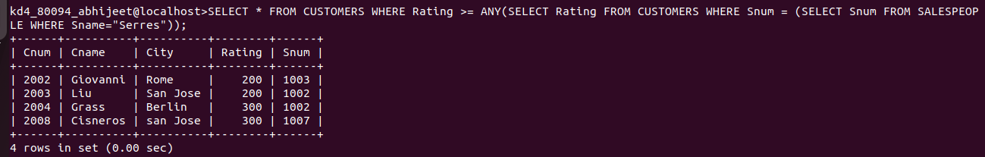

Q.2 Write a query using any or all that will find all salespeople who have no customers located in their city.
Ans.
SELECT Snum, Sname FROM SALESPEOPLE WHERE (Snum ,City) NOT IN (SELECT Snum, City FROM CUSTOMERS);

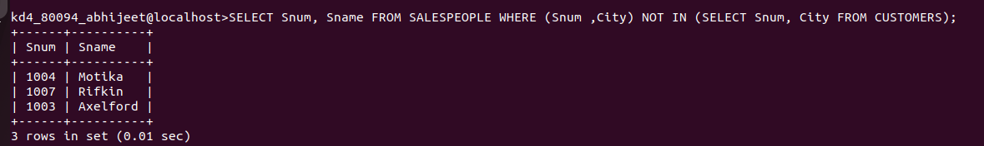

Q.3 Write a query that selects all orders for amounts greater than any for the customers in london.
Ans.
SELECT * FROM ORDERS WHERE Amt> ANY (SELECT Amt FROM ORDERS WHERE Cnum IN (SELECT Cnum FROM CUSTOMERS WHERE City IN('London')));

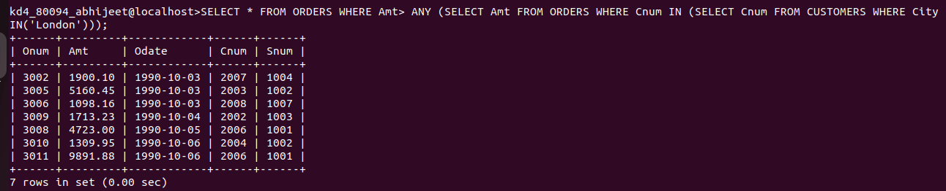
Q.4 Write the above query using MIN or MAX.
Ans.
SELECT * FROM ORDERS WHERE Amt> (SELECT MIN(Amt) FROM ORDERS WHERE
Cnum IN (SELECT Cnum FROM CUSTOMERS WHERE City IN('London')));
